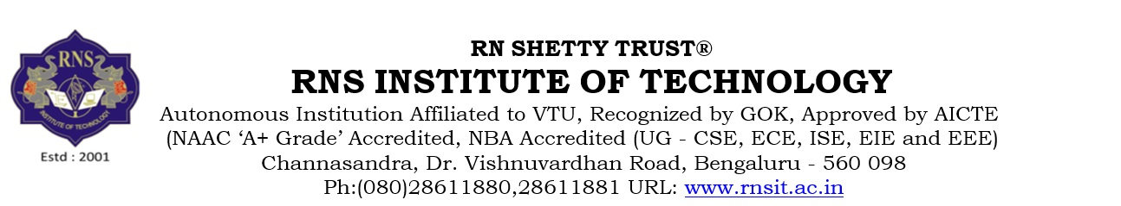

APPLICATION FORM (Technical, Non-Teaching, Admin)

General Instructions:
Fill the form in BLOCK LETTERS. All columns and fields are Mandatory.

Date of Application:
Position Applied for:
Details of relatives employed in RNSIT Institutions:

EMPLOYEE INFORMATION

Full Name
Gender  (Male/Female) |  | Date of Birth  (DD/MM/YYYY) |  |  | PAN No.
Father’s/Spouse Name |  | Mother Tongue |  |  | Aadhar No.
Marital Status
Birth Place |  | State |  |  | Nationality
Physically Challenged | (Yes / No) | Mobile No. 1 |  |  | Emergency Contact No.
 |  | Mobile No. 2
E-mail ID
Category SC/ST/OBC/GEN |  | Religion |  |  | Caste
Permanent Address
Present Address
Are you a EPF member in previous employment? If yes, give the details of UAN / PF Account No

EDUCATION DETAILS

Qualification | Specialization / Discipline | Name of Institution | Board / University | Types of Course (Full Time / Part Time) | Percentage/ CGPA | Date of Degree Award
Diploma
UG
PG
Ph.D

Any Health-related problems (including Physical/ Visual Disability and Chronic Aliments).
Languages known & fluency: (Good/ Fair/ Slight)
Language Understand Speak Read Write

INDUSTRIAL OR ANY EXPERIENCE OTHER THAN TEACHING

Sl.  No | Employer | Position held | Date of joining | Date of leaving | Gross Salary

PROFESSIONAL TRAINING/SEMINARS/WORKSHOPS ATTENDED

Sl. No | Nature of the course | Organizing  Agency | Place | Duration

- Any Awards certificates received or any other special work done.

- Hobbies or any other Extra Curricular activities:

- Indicate your participation / involvement in academic accreditation and organizing seminars/conferences /workshop

- Write a short description about the following:

  - Please indicate as to why you wish to join RNSIT Institutions?

  - How in your opinion do you meet the job requirement?

  - A short paragraph about the development work that you would like to take up at RNSIT.

PROFESSIONAL REFRENCE

S. No. | Name of the Person | Company | Place | Contact No.

I hereby certify that all information provided in this document along with the certificates / testimonials are true and accurate to the best of my knowledge and belief. I understand that any misrepresentation of information may lead to termination of services.

Signature

Date:

Place:

